Lab 8 - CSS Selectors

Instructions
- Answer the below question in the boxes if needed.
- For coding exercises, code on your computer and zip all your code before submission.
- Please submit the assignment tafter you finish.
- NO INLINE CSS CAN BE USED FOR THIS LAB

Part 1: Selectors
Steps:

- Go to VS Code and open the folder that we created in Lab 1
- Create a new HTML file inside the folder name "css-selector.html". You can use the HTML skeleton we included in Chapter 1.
- Build HTML elements inside the body to replicate the screenshot below. Both elements are paragraphs. (<p> tag). Use internal or external CSS to style it as follows.
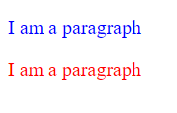

Part 2: Background

- In your internal or external CSS, Add CSS to recreate the screenshot below. You should not remove the CSS you created in Part 1.
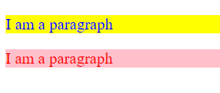

Part 3: Border

- In your internal or external CSS, Add CSS to recreate the screenshot below. You should not remove the CSS you created in Part 1 and 2. The border width is 5px, style is dotted for your reference.

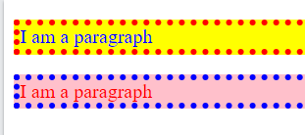

- Zip the HTML and CSS files (if you are using external CSS) and upload it to the Learning Management System

Part 4: CSS Combinators

- Go to VS Code and open the folder that we created in Lab 1
- Create a new HTML file inside the folder name "css-combinators.html". You can use the HTML skeleton we included in Chapter 1.
- Copy the following snippet into the HTML body.
<div>
<p>This is a paragraph inside a div element.</p>
<p>This is another paragraph inside a div element.</p>
<span><p>This a paragraph inside a span element, inside a div element.</p></span>
</div>
<p>This is a paragraph, not inside a div element.</p>
<p>This is another paragraph, not inside a div element.</p>

- Change the color of all <p> elements, that are descendants of <div> elements, to "red".
- Change the color of all <p> elements, that are immediate children of <div> elements, to "green".
- Zip the final HTML/CSS files from part 3, and the HTML/CSS file from part 4 into the same zip file then submit.

